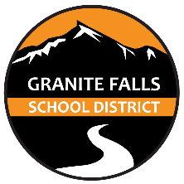

Granite Falls School district is asking organizations and community members to volunteer to be a part of our Community Engagement Board during the 2022-2023 school year. We are trying to revamp our truancy program by creating a more collaborative process involving agencies and schools to problem solve, offer support, and find solutions with the community for these young people and families in our community.

In 1995, and updated in 2016, the Washington State Legislature passed a compulsory attendance law known as the “BECCA Bill”. The legislature’s intent is to ensure that all children attend and complete an education program provided by the state. Under the state law, the school district is obligated to take steps to eliminate absences. As part of the process the student and family are scheduled to attend our community engagement board.

Our community engagement board will attempt to find out why the student has been absent from our school. The board consists of school personnel, juvenile court employees, and community members. The board collaborates with the student and family to explore the barriers and possible solutions to the truant behavior and creates a contract to improve attendance and intervene prior to filing a truancy petition with the juvenile court. The contract may refer the student to participate in counseling, medical screenings, drug & alcohol treatment, change of schedule, update academic requirements, etc. The contract is monitored by the school district to support the student’s goals.

We meet on (date and time of truancy board) located at (address). The time commit is (how often the board meets and length of time for each date).

Your support would be appreciated to help guide these young people towards success and to improve our community as a whole. Please call (name of point person) at (phone number) with any questions or if you are interested in volunteering.

Thank you,

(Name, email and phone # of point person)