**Get Your Microsoft Office ProPlus for FREE!**

Office ProPlus is offered free of charge to all GFSD students, faculty and staff.

Please be aware that anytime you install software there is a risk that your computer will run slower or there could be more serious consequences such as needing to do complete re-installation of the OS and software. You would be wise to back up your computer completely. Please read through the following before proceeding:

In downloading and installing Office, you agree that you do so at your own discretion and risk and that you will be solely responsible for any damage to your device, and all costs associated therein, and or property or loss of data that results. The Granite Falls School District shall not provide any support for Office on any personal devices and shall not pay for nor reimburse for any costs associated with hardware or software failures as a result of downloading, installing, transmitting, or displaying Office on a personal device.

1. Log onto the O365 portal: [https://login.microsoftonline.com](https://login.microsoftonline.com/)
   1. **Username**: studentID@gfalls.wednet.edu (for example 0555555@gfalls.wednet.edu)
   2. **Password**: your GFSD password
   3. You will be greeted with a Welcome page and you will see a “**Install Software**” button

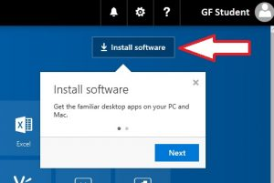

* 1. Click on the button and follow the steps.

If you have trouble accessing the O365 portal please email [support@gfalls.wednet.edu](mailto:support@gfalls.wednet.edu) for assistance.