Course Registration

TIP SHEET
Granite Falls High School

ACCESS ONLINE REGISTRATION

- Log into Skyward. Please see the Skyward registration instructions on the back page.
You MUST log-in as a student. (If you don’t know your log-in for Skyward, see Crystal Johnson at the Middle School.)

WHEN SELECTING YOUR CLASSES . . .

We have already added in some classes for you!
- Students can no longer delete what was entered by the counselors. If you wish to make a change request, email your counselor at whartley@gfalls.wednet.edu
- Be sure to add BOTH semesters for a course if it is a year-long course.
(Skyward may or may have done this automatically.)
- Be sure to enter in six (6) credits worth of classes AND
four (4) alternates in case your first choice is not available.

ADDING ALTERNATE CLASSES

- Once you have entered 6.0 credits worth of classes, click on the top tab
marked “View Alternates.”
- Add four (4) alternates using the same process you used to select classes.
- If an alternate is a yearlong class, request the first semester only.
- Alternates are very important if a class that you requested does not run due to
insufficient sign-ups, funding, or conflicts with another class you requested that
is only available during the periods.
- If you do not provide alternates, or if your alternates also don’t run or conflict with
your other requests, your counselor will choose courses for you.

LAST STEP!

- Do you have six (6) credits worth of requests?
- Do you have four (4) alternates listed? In your preferred order?
- Do your choices help you meet graduation requirements?
- Do your choices keep your options open after high school?
- When you are done, just exit out or save it as a pdf.

REGISTERING IN SKYWARD
- Go to Skyward. Log-in as a student. Type in your login and password.
- Click the Schedule tab on the left-hand side.
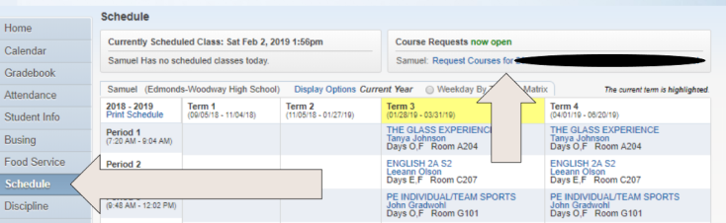
- On the top right of the screen it says “Course Requests now open.”
Click into the hyperlink below titled “Request Courses for 2024-2025 . . .”
- The window called “Selected Courses” to the right shows courses
already added by the office.
- The window called “Available Courses for 2024-25” to the left shows courses you may select.
To choose your Required and Elective courses (1st choices)
- Use the search window at the bottom of the screen and type the Course Code or
Course Description of one of your choices.
- Highlight desired course – codes are listed alphabetically.
- Click “Add Course” button.
- Continue adding courses until you have a full schedule of courses.
To delete:
- Highlight desired course and Click “Remove Course” button.
To input Alternates: (2nd choices if you can’t get 1st choices)
- Click “Request Alternates” tab.
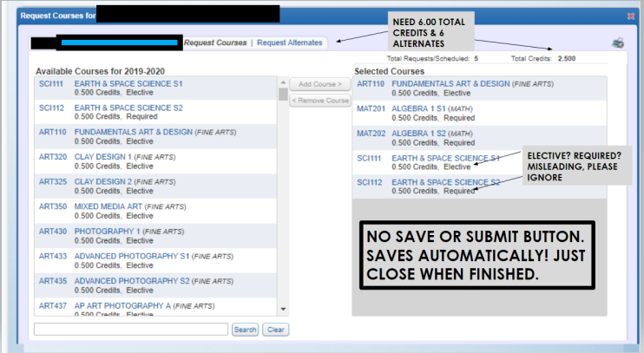
- Use the search window at the bottom of the screen and type the Course Code or
Course Description of one of your 2nd choices.
- Highlight desired course click “Add Course” button
- Use the arrow icons to order your Alternate courses in your order of priority.

